Table of Contents:
Chuckery Race 3
A view of the Chuckery Race wall and Cathedral Rock, 1930 (Courtesy Cuyahoga Falls Historical Society) 3
Chuckery Race, 1908 (Courtesy Cuyahoga Falls Historical Society) 3
Chuckery Race, March 2019 (Summit Metro Parks) 4
Dam 5
Scaffolding for dam construction erected above the big falls, 1912 (Courtesy Cuyahoga Falls Historical Society) 5
Gorge Dam being constructed, July 1912 (Courtesy Cuyahoga Falls Historical Society) 5
Dam construction, August 1912 (Courtesy Cuyahoga Falls Historical Society) 6
Dam construction, August 1912 (Courtesy Cuyahoga Falls Historical Society) 6
The newly opened dam, c. 1912 (Courtesy Cuyahoga Falls Historical Society) 7
Aerial photograph showing dam, power plant, and Riverside Park, 1920’s (Courtesy Cuyahoga Falls Historical Society) 7
Footbridge Across the Cuyahoga Below the Dam 8
Postcard Showing the footbridge at the Gorge, date unknown (Courtesy Mary McClure) 8
Foot bridge shown downriver from a picnic area, date unknown (Summit Metro Parks) 8
Foot bridge shown in disrepair, date known (Courtesy Cuyahoga Falls Historical Society) 9
Foot bridge being repaired. The Penstock can be seen in the background. Date unknown (Courtesy Cuyahoga Falls Historical Society) 10
Foot bridge pylon, March 2019 (Summit Metro Parks) 11
Foot bridge pylons as viewed from the north bank of the river, March 2019 (Summit Metro Parks) 11
Northern Ohio Traction & Light Hydro Plant 12
Photograph showing the hydro plant and staircase leading down hillside, date unknown (Courtesy Cuyahoga Falls Historical Society) 12
The hydro plant as viewed from the location of the present High Level bridge, date unknown (Courtesy Cuyahoga Falls Historical Society) 13
Hydro plant remains, March 2019 (Summit Metro Parks) 13
Hydro Plant Remains, March 2019 (Summit Metro Parks) 14
Hydro Plant remains, March 2019 (Summit Metro Parks) 14
NOT&L Penstock 15
The Penstock as viewed from the northern river bank, 1928 (Courtesy Cuyahoga Falls Historical Society) 15
The Penstock and a “standpipe” as viewed from the river, February 1928 (Summit Metro Parks) 15
Old Traction Bridges 16
The Akron, Bedford, and Cleveland Bridge (foreground) and the Akron Traction Company bridge- present Front St. bridge- (background) prior to the dam construction, c. 1903-1912 (Courtesy Cuyahoga Falls Historical Society) 16
The Akron, Bedford, and Cleveland Bridge (upper) and the Akron Traction Company bridge- present Front St. bridge- (lower) prior to the dam construction, c. 1903-1912 (Courtesy Mary McClure) 16
The removal of the 1903 Akron, Bedford, and Cleveland traction bridge, c. 1979 ((Courtesy Cuyahoga Falls Historical Society) 17
Remains of the AB&C Traction bridge pylons, March 2019 (Summit Metro Parks) 17
Gorge Picnic Shelter 18
Picnic Shelter shown shortly after construction, 1937 (Summit Metro Parks) 18
Picnic shelter as viewed from the west. The Riverview park dance hall, The Roseland, can be seen in the background. 1937. (Courtesy Cuyahoga Falls Historical Society) 18
The Gorge shelter with its walls removed, 1939. (Summit Metro Parks) 19
Old Maid’s Kitchen 20
Old Maid’s Kitchen during the Mary Campbell Memorial Dedication, 1935 (Summit Metro parks) 20
Old Maid’s Kitchen showing staircase from above, unknown date. (Courtesy Cuyahoga Falls Historical Society) 20
Victorian visitors at Old Maid’s Kitchen, date unknown. (Courtesy Mary McClure) 21
Natural Attractions 22
Visitors inside unknown cave, January 1930 (Summit Metro Parks) 22
Unknown cave, possibly Fern Cave, date unknown (Summit Metro Parks) 22
Cathedral Rock at the beginning of the Chuckery Race, date unknown (Courtesy Cuyahoga Falls Historical Society) 23
Visitor near large rock located in original river bed, date unknown (Courtesy Mary McClure) 23
Visitor to Gorge along original river bank, date unknown (Courtesy Mary McClure) 24
Original Big Falls 25
Victorian visitors to the Big Falls, date unknown (Courtesy Mary McClure) 25
A view of the Big Falls. Victorian visitors shown in front of and on trail behind on the southern bank. (Courtesy Mary McClure) 25

Chuckery Race
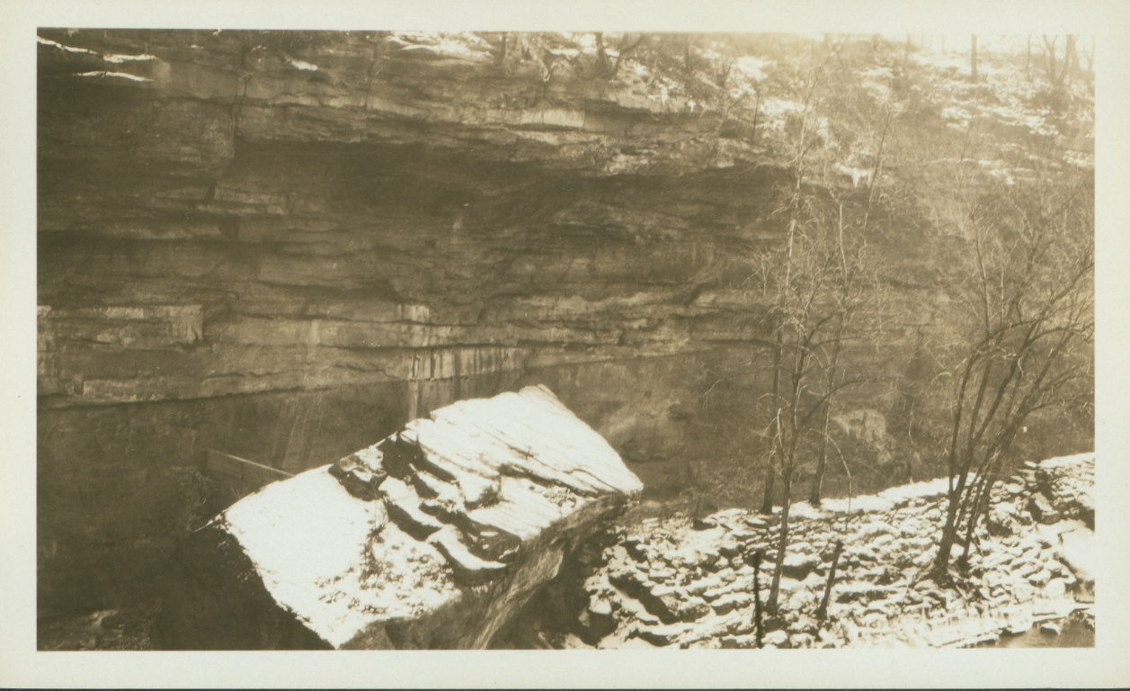
A view of the Chuckery Race wall and Cathedral Rock, 1930 (Courtesy Cuyahoga Falls Historical Society)
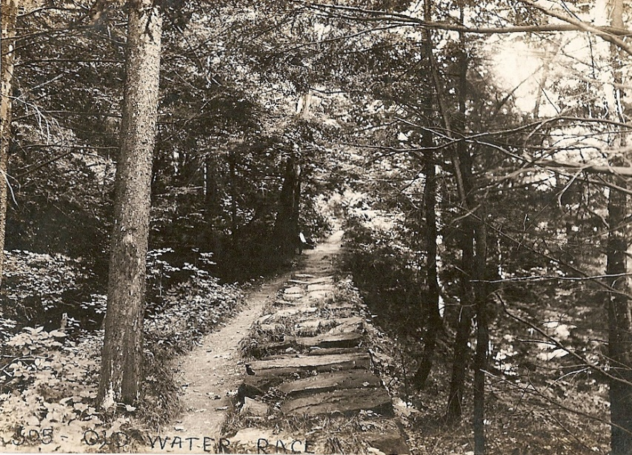
Chuckery Race, 1908 (Courtesy Cuyahoga Falls Historical Society)

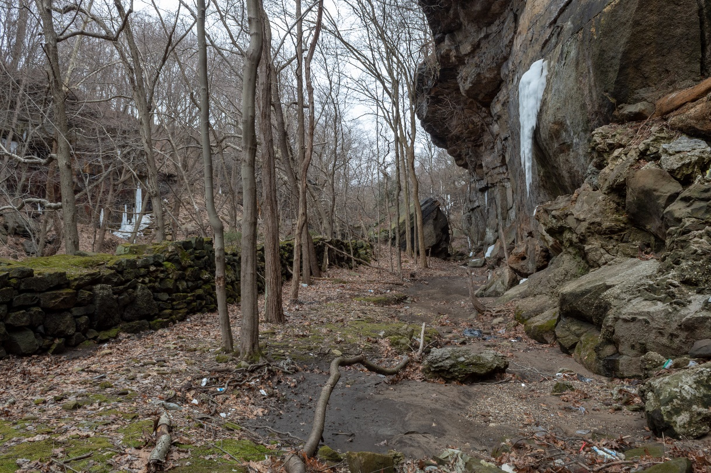
Chuckery Race, March 2019 (Summit Metro Parks)

Dam
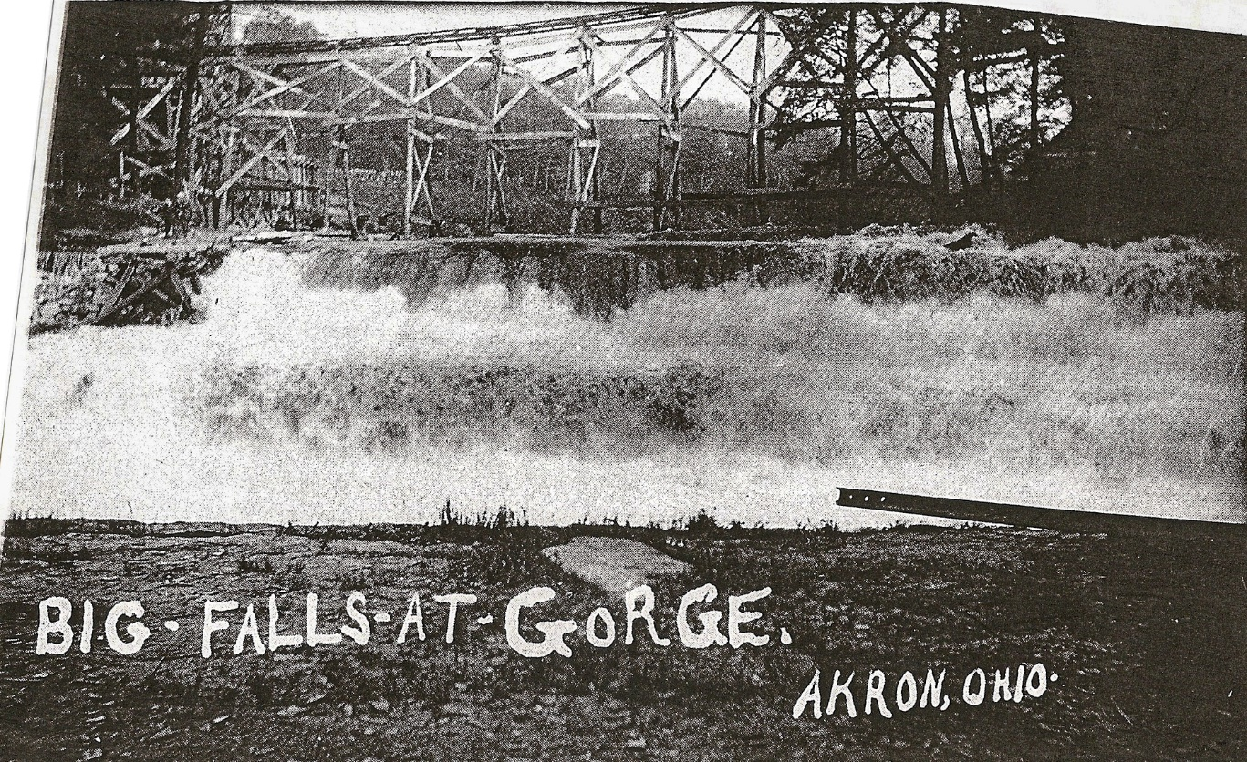
Scaffolding for dam construction erected above the big falls, 1912 (Courtesy Cuyahoga Falls Historical Society)
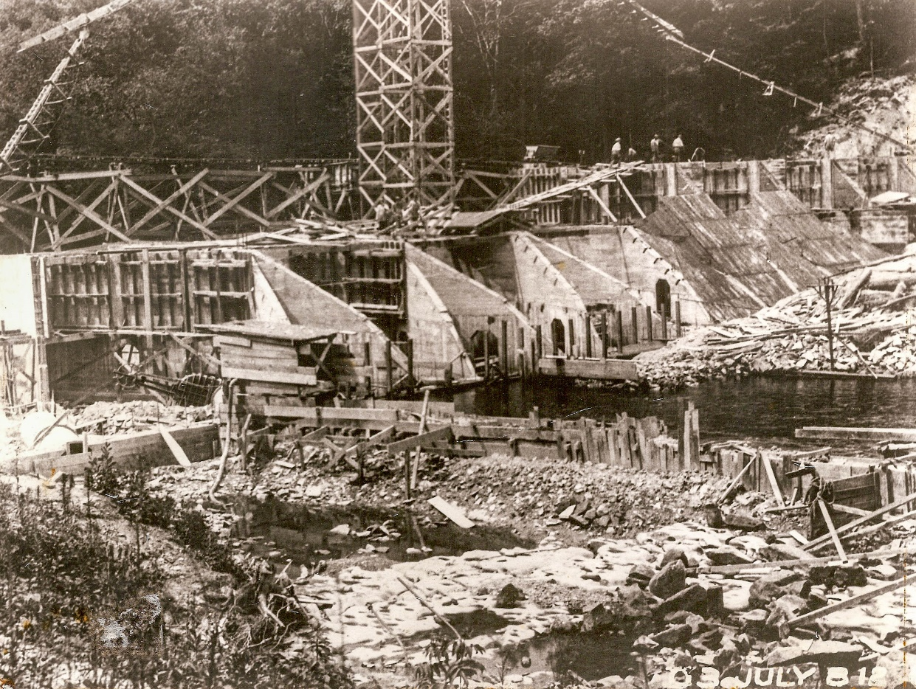
Gorge Dam being constructed, July 1912 (Courtesy Cuyahoga Falls Historical Society)
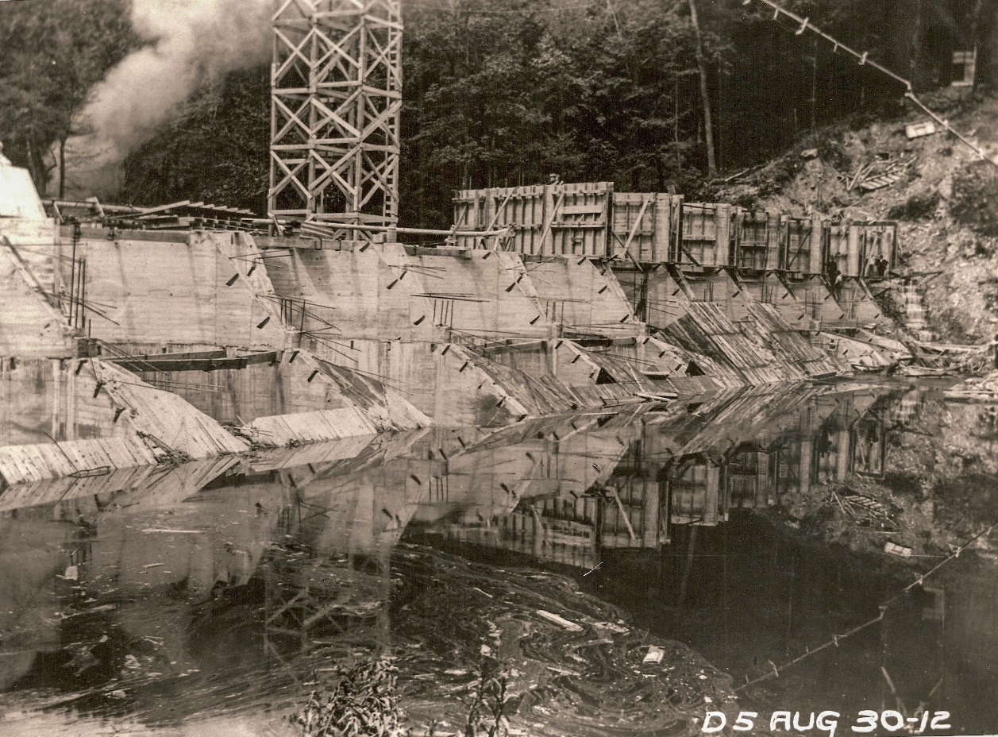
Dam construction, August 1912 (Courtesy Cuyahoga Falls Historical Society)
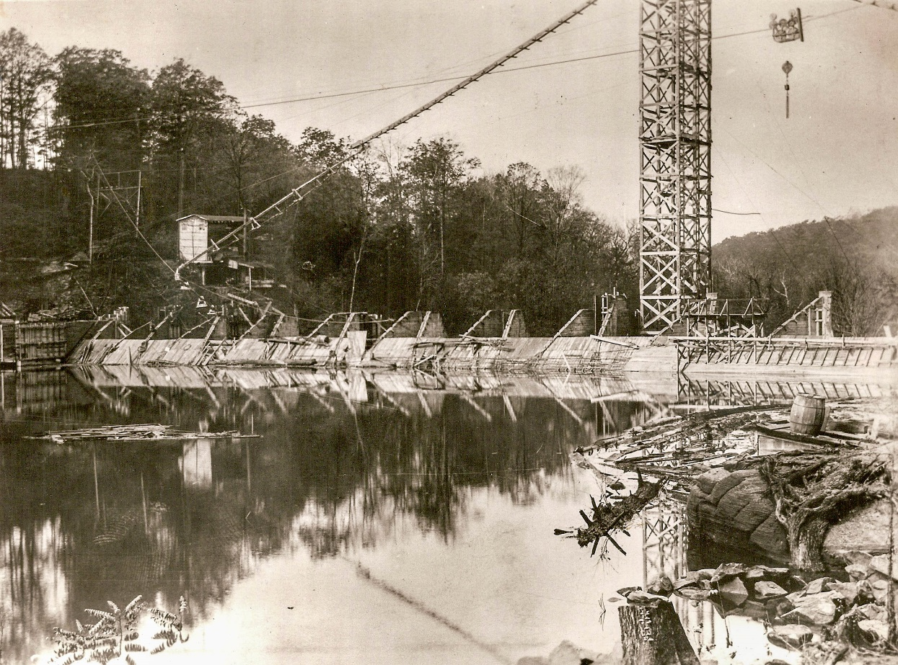
Dam construction, August 1912 (Courtesy Cuyahoga Falls Historical Society)
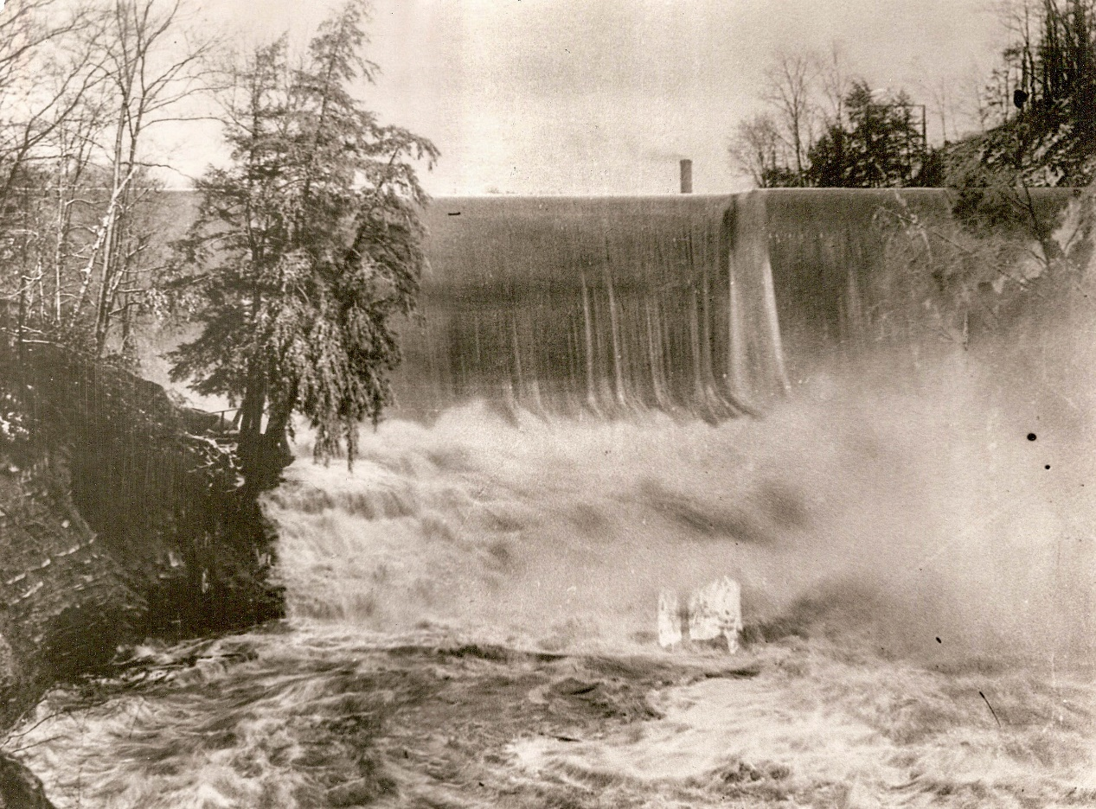
The newly opened dam, c. 1912 (Courtesy Cuyahoga Falls Historical Society)
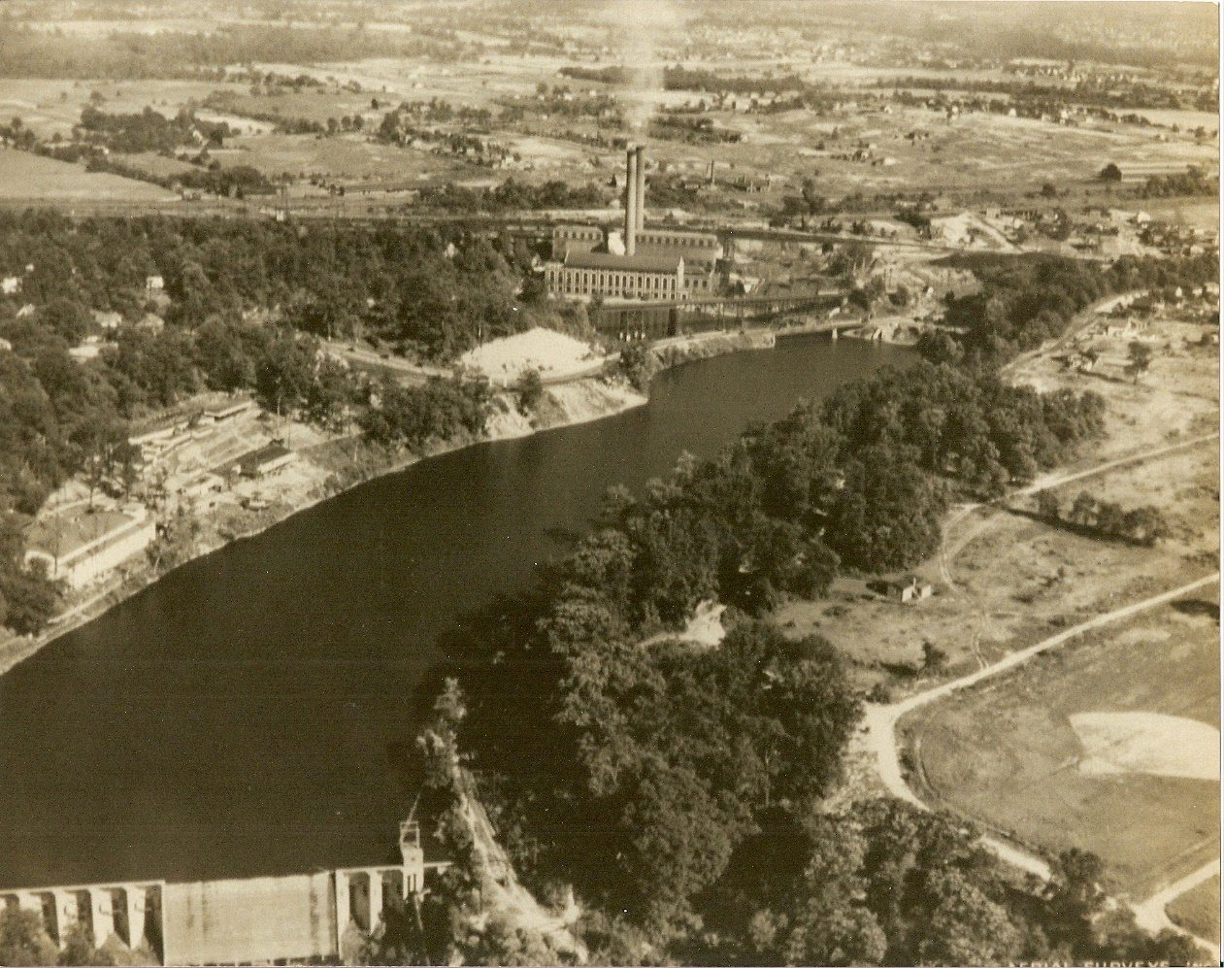
Aerial photograph showing dam, power plant, and Riverside Park, 1920’s (Courtesy Cuyahoga Falls Historical Society)

Footbridge Across the Cuyahoga Below the Dam
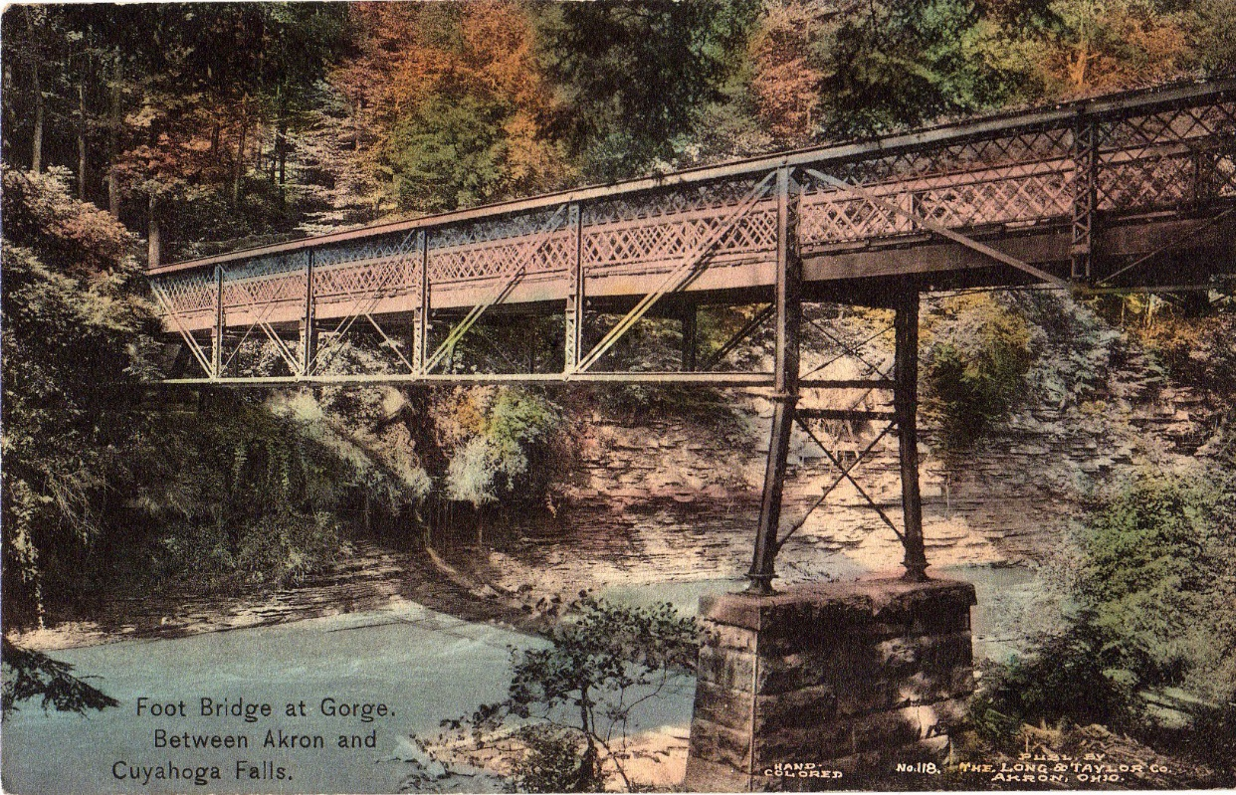
Postcard Showing the footbridge at the Gorge, date unknown (Courtesy Mary McClure)
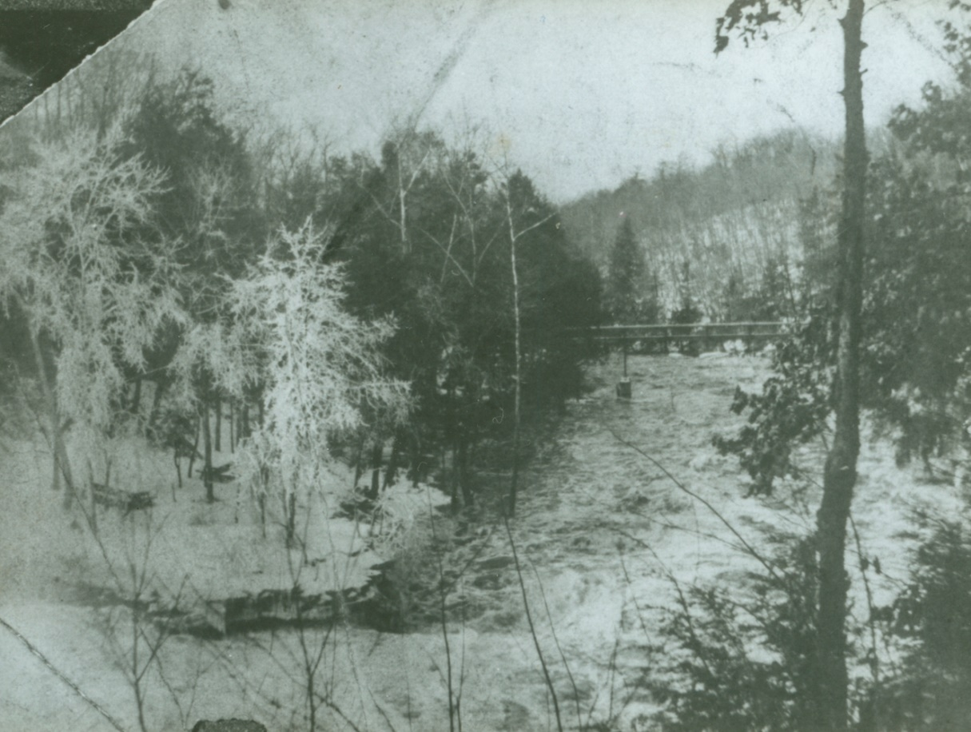
Foot bridge shown downriver from a picnic area, date unknown (Summit Metro Parks)
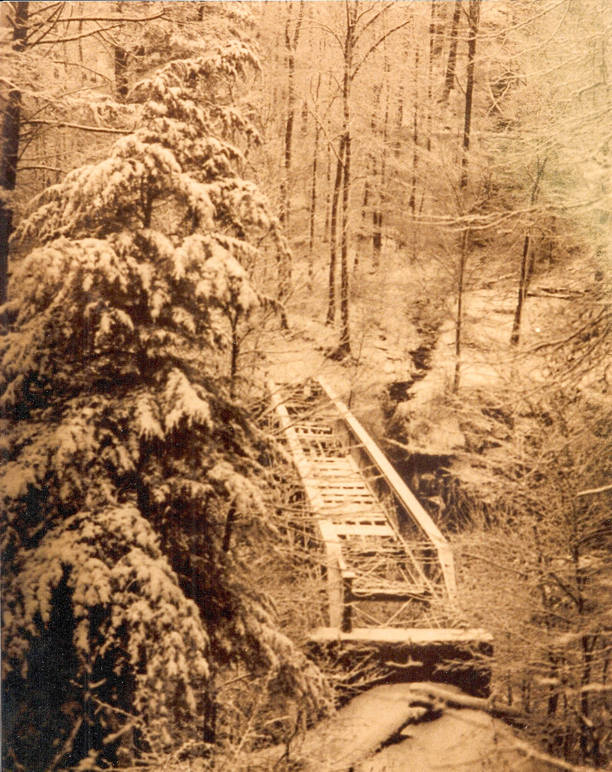
Foot bridge shown in disrepair, date known (Courtesy Cuyahoga Falls Historical Society)
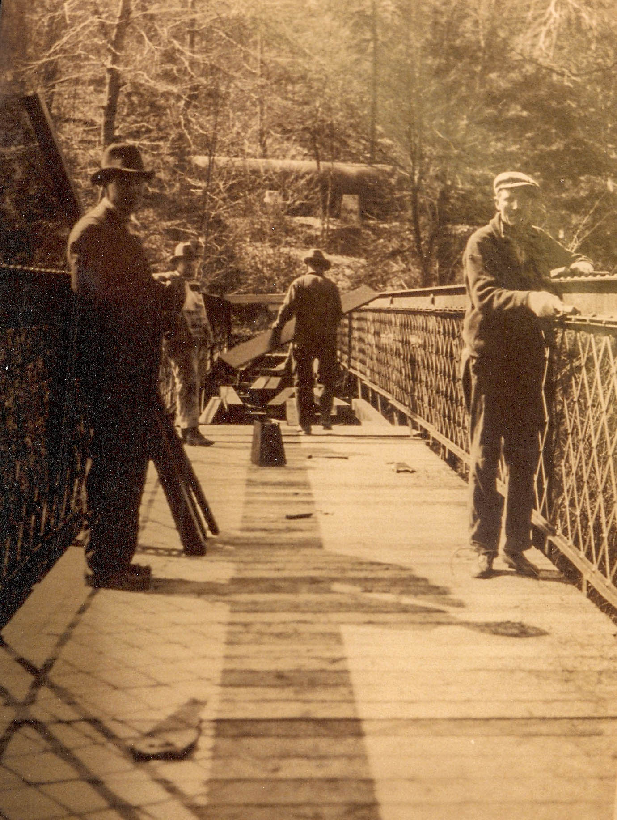
Foot bridge being repaired. The Penstock can be seen in the background. Date unknown (Courtesy Cuyahoga Falls Historical Society)
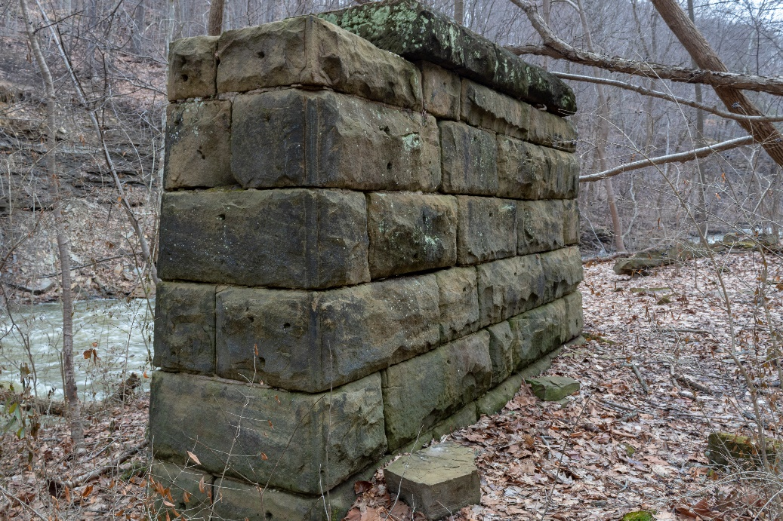
Foot bridge pylon, March 2019 (Summit Metro Parks)
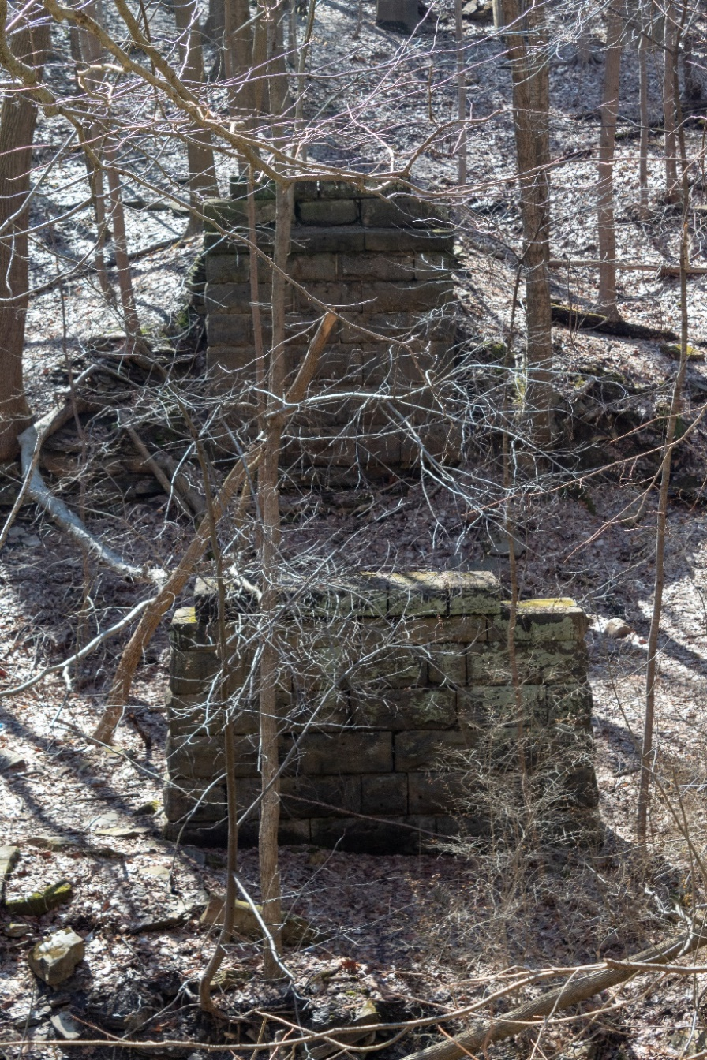
Foot bridge pylons as viewed from the north bank of the river, March 2019 (Summit Metro Parks)

Northern Ohio Traction & Light Hydro Plant
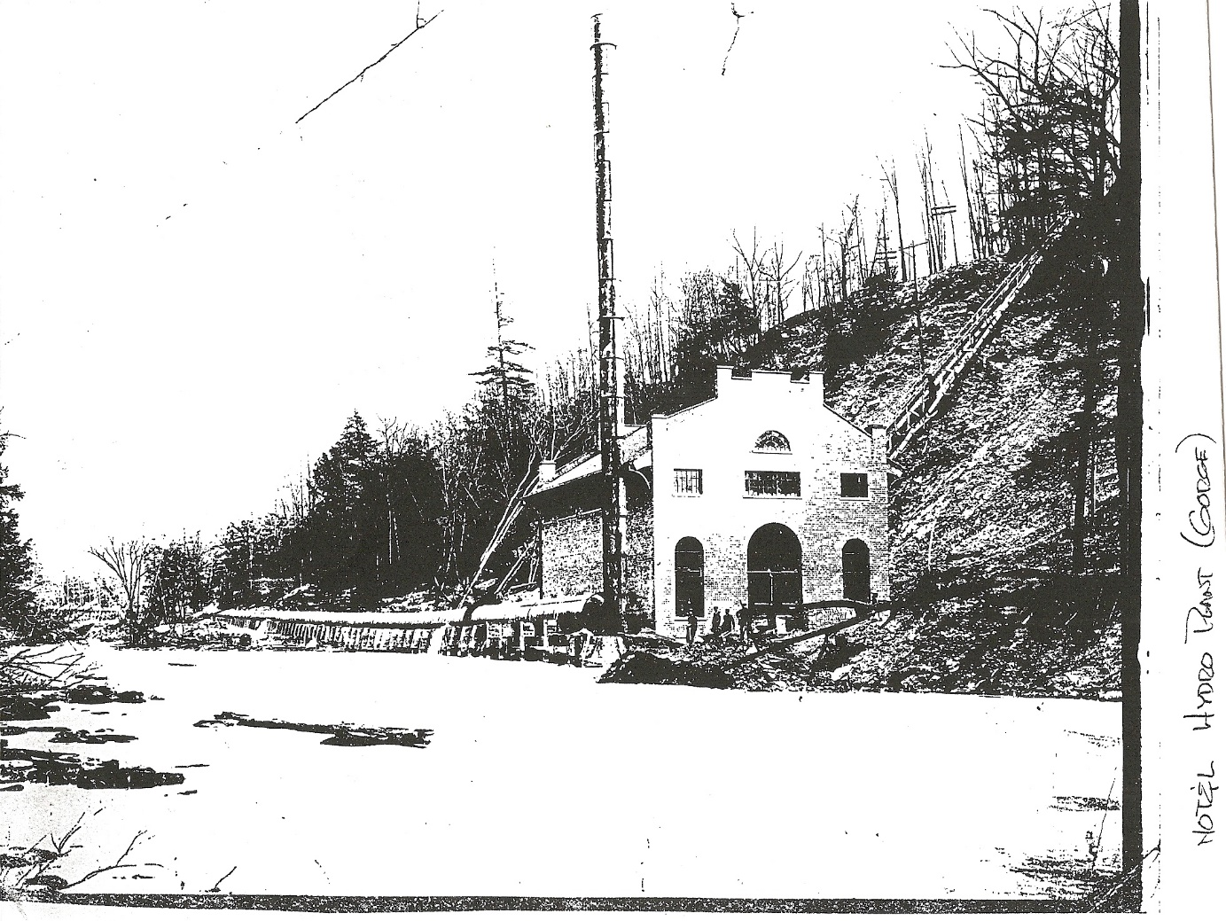
Photograph showing the hydro plant and staircase leading down hillside, date unknown (Courtesy Cuyahoga Falls Historical Society)
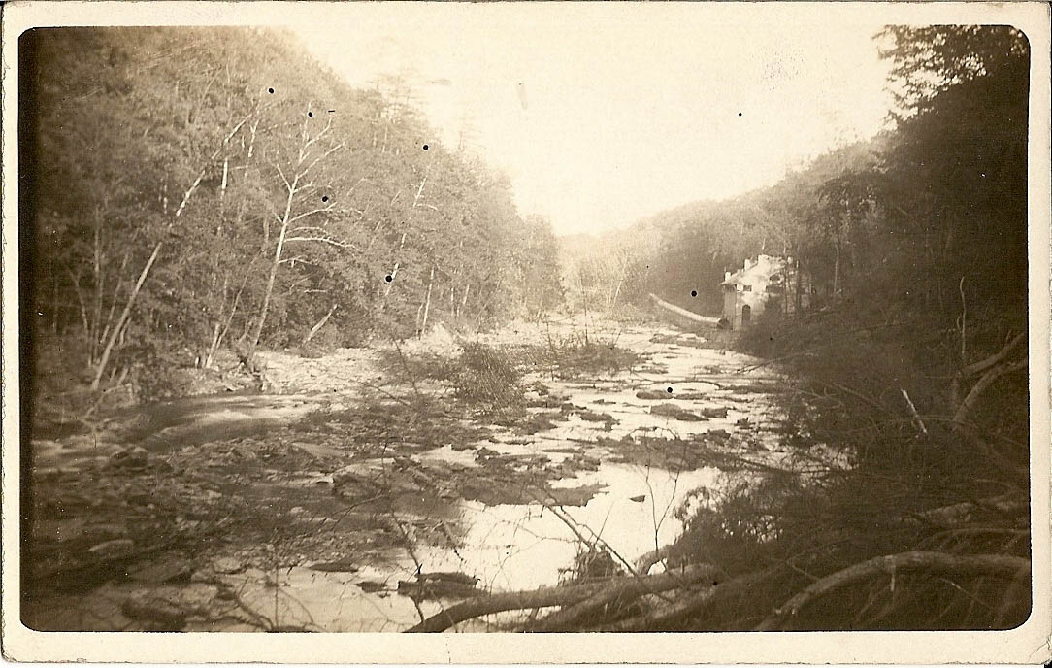
The hydro plant as viewed from the location of the present High Level bridge, date unknown (Courtesy Cuyahoga Falls Historical Society)
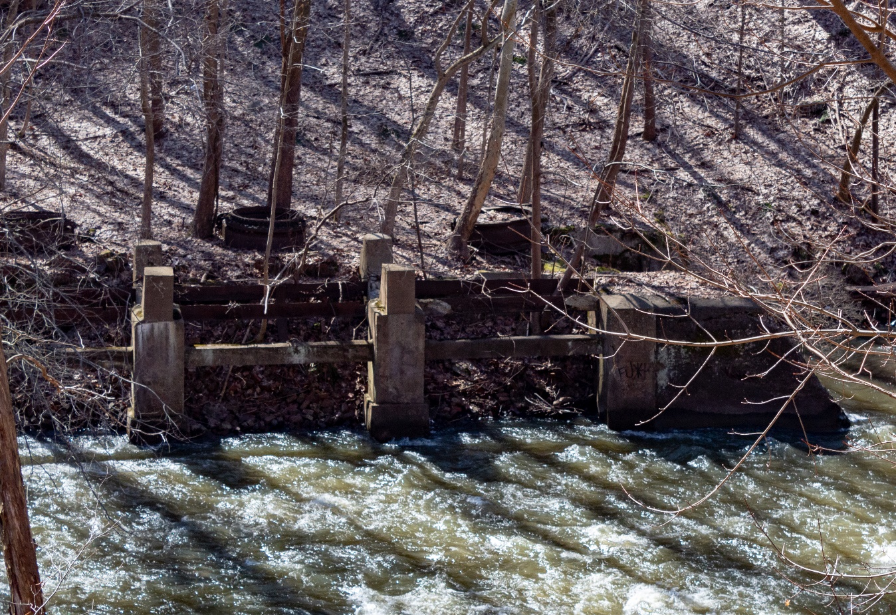
Hydro plant remains, March 2019 (Summit Metro Parks)
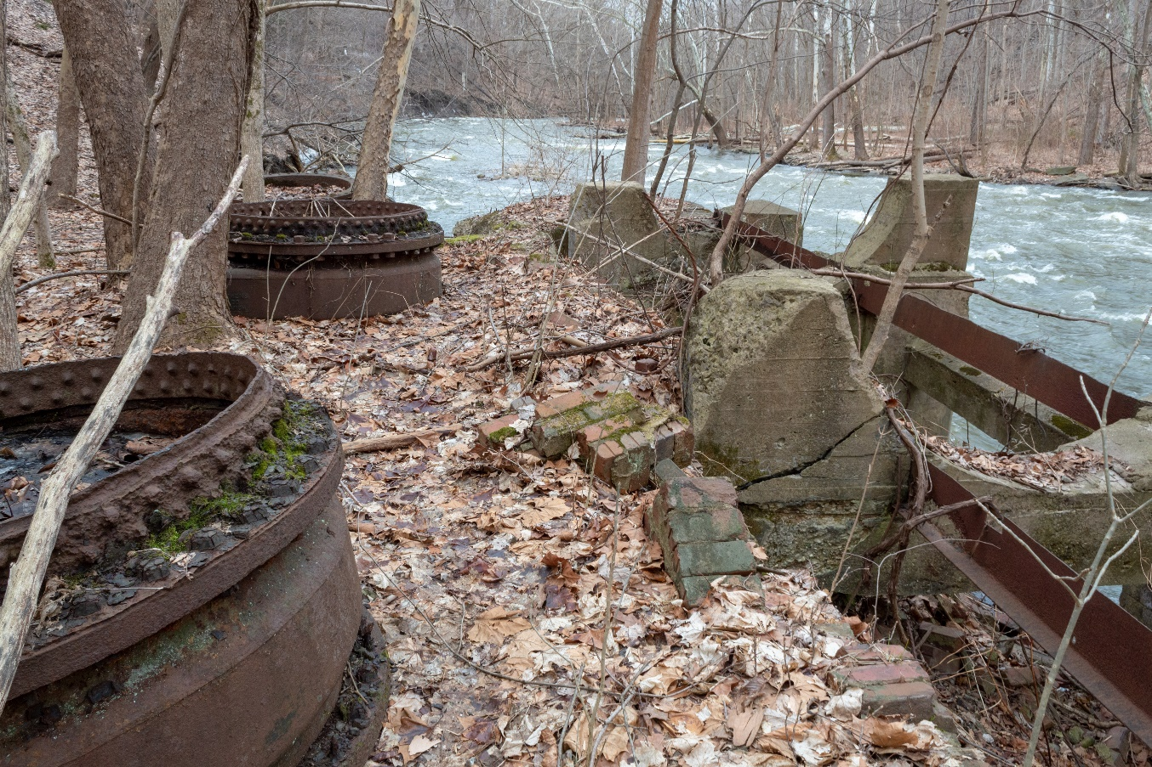
Hydro Plant Remains, March 2019 (Summit Metro Parks)
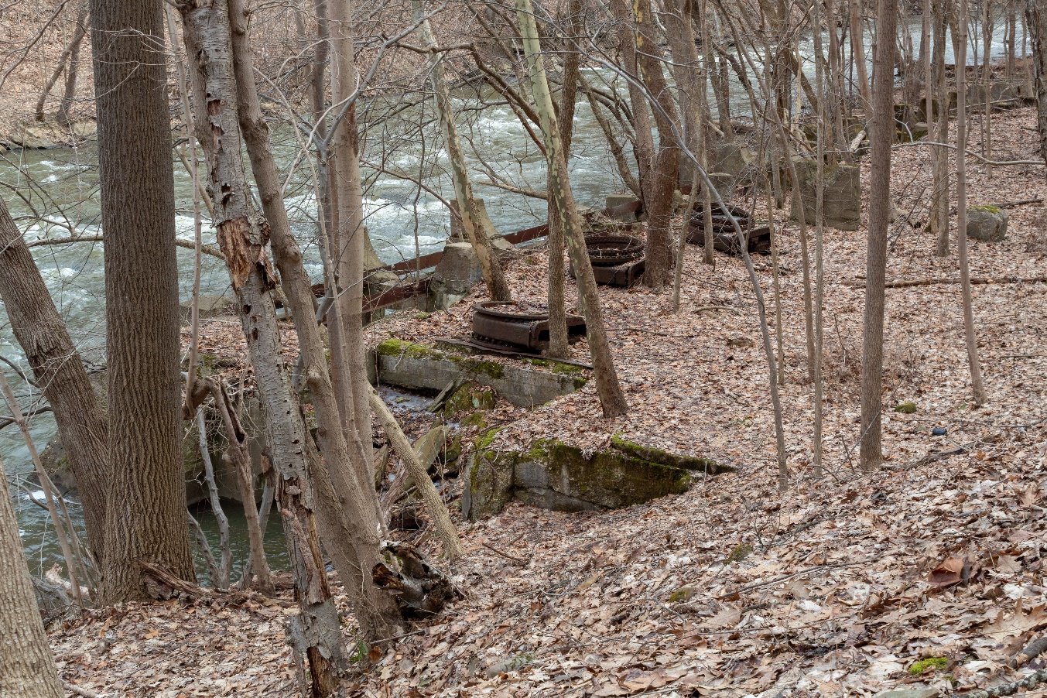
Hydro Plant remains, March 2019 (Summit Metro Parks)

NOT&L Penstock
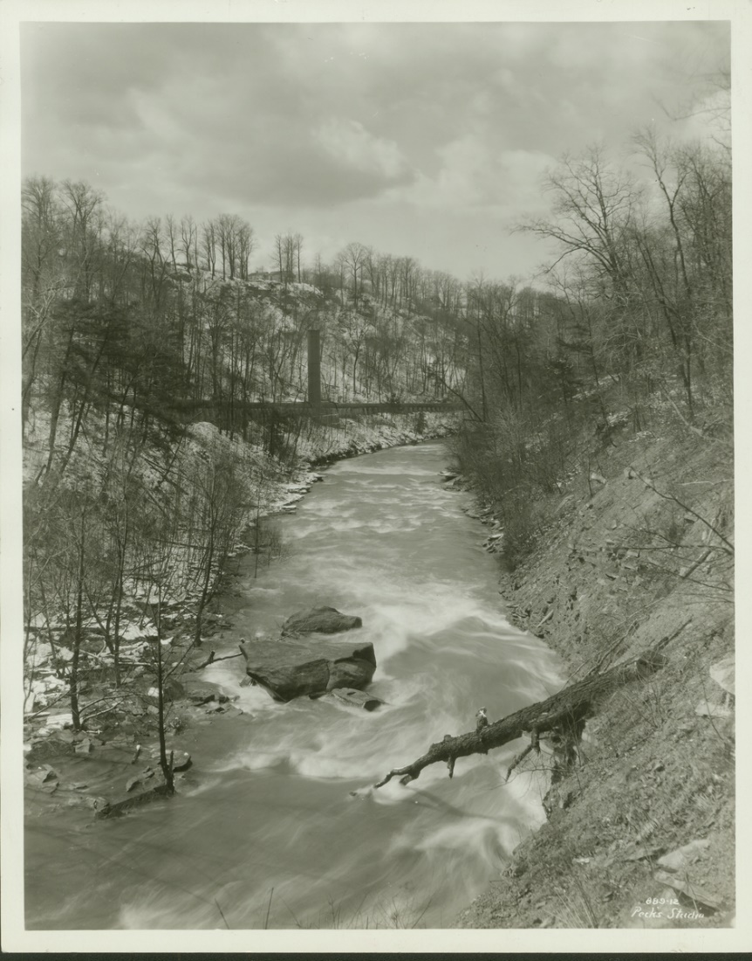
The Penstock as viewed from the northern river bank, 1928 (Courtesy Cuyahoga Falls Historical Society)
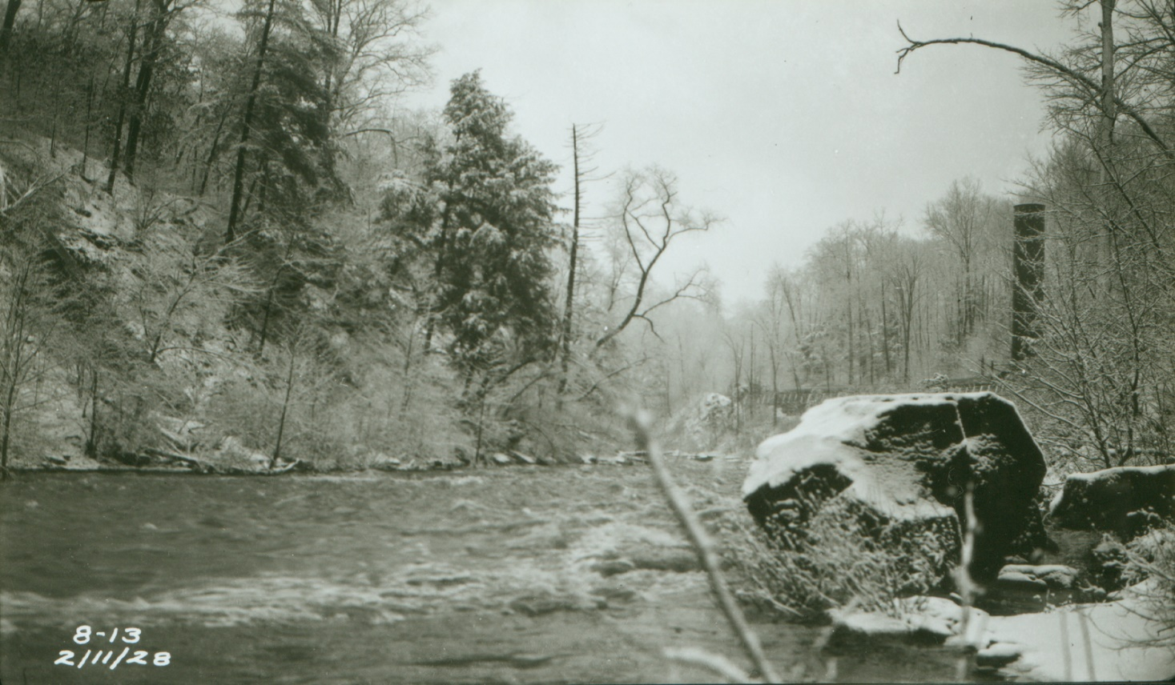
The Penstock and a “standpipe” as viewed from the river, February 1928 (Summit Metro Parks)
Old Traction Bridges
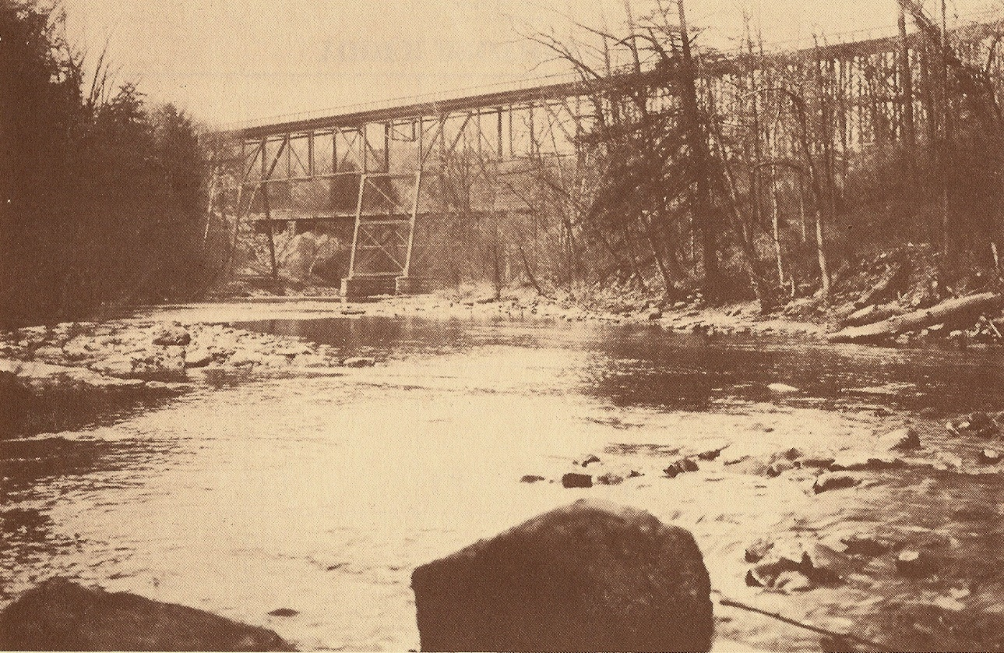
The Akron, Bedford, and Cleveland Bridge (foreground) and the Akron Traction Company bridge- present Front St. bridge- (background) prior to the dam construction, c. 1903-1912 (Courtesy Cuyahoga Falls Historical Society)
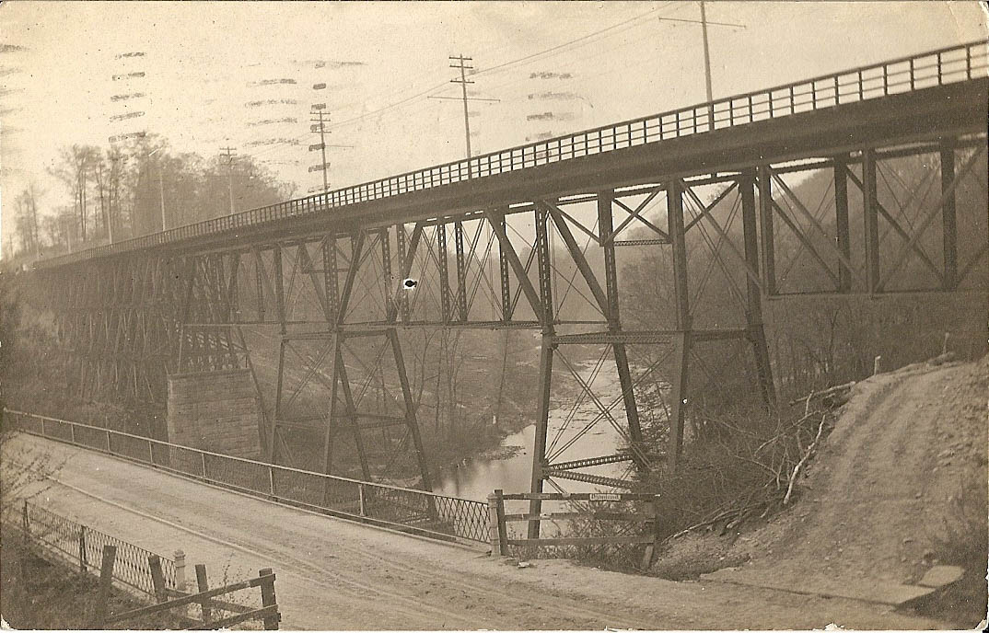
The Akron, Bedford, and Cleveland Bridge (upper) and the Akron Traction Company bridge- present Front St. bridge- (lower) prior to the dam construction, c. 1903-1912 (Courtesy Mary McClure)

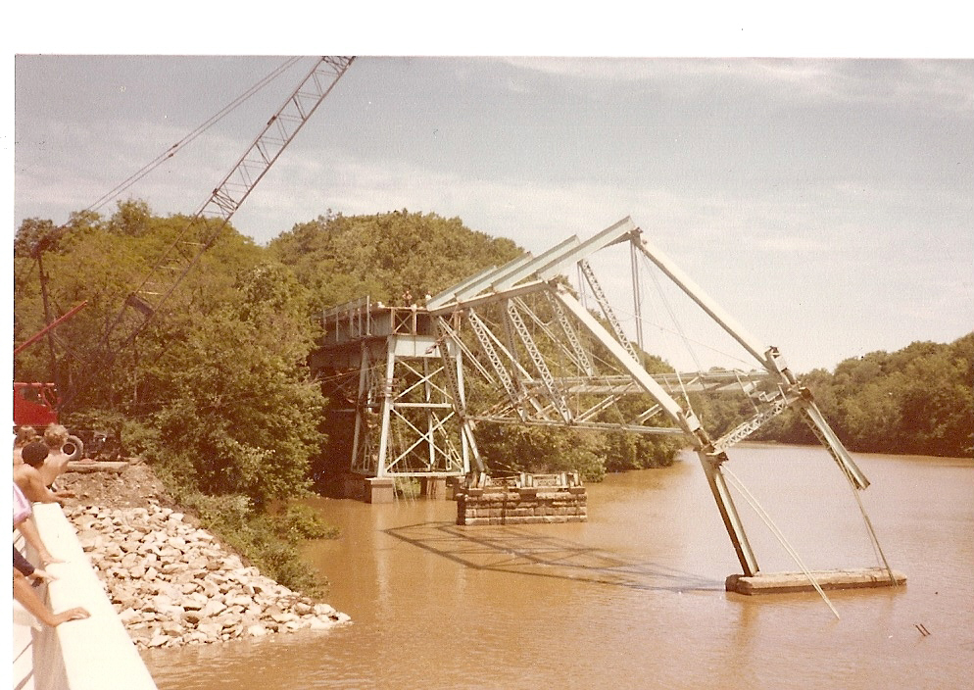
The removal of the 1903 Akron, Bedford, and Cleveland traction bridge, c. 1979 ((Courtesy Cuyahoga Falls Historical Society)
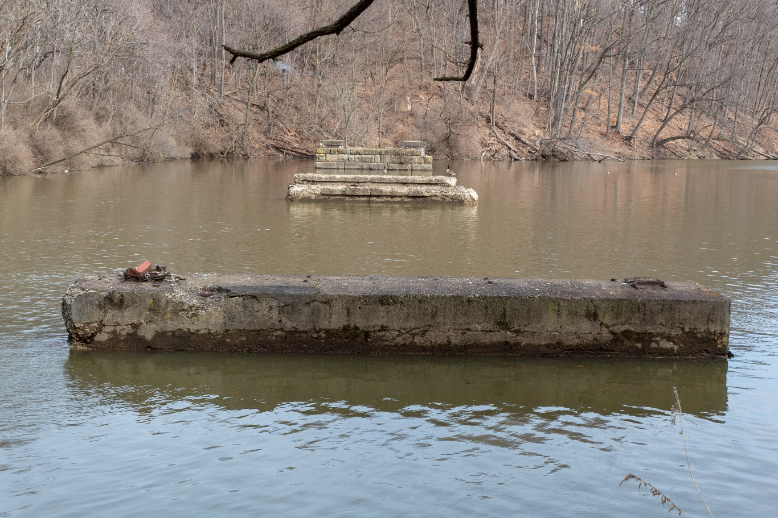
Remains of the AB&C Traction bridge pylons, March 2019 (Summit Metro Parks)

Gorge Picnic Shelter
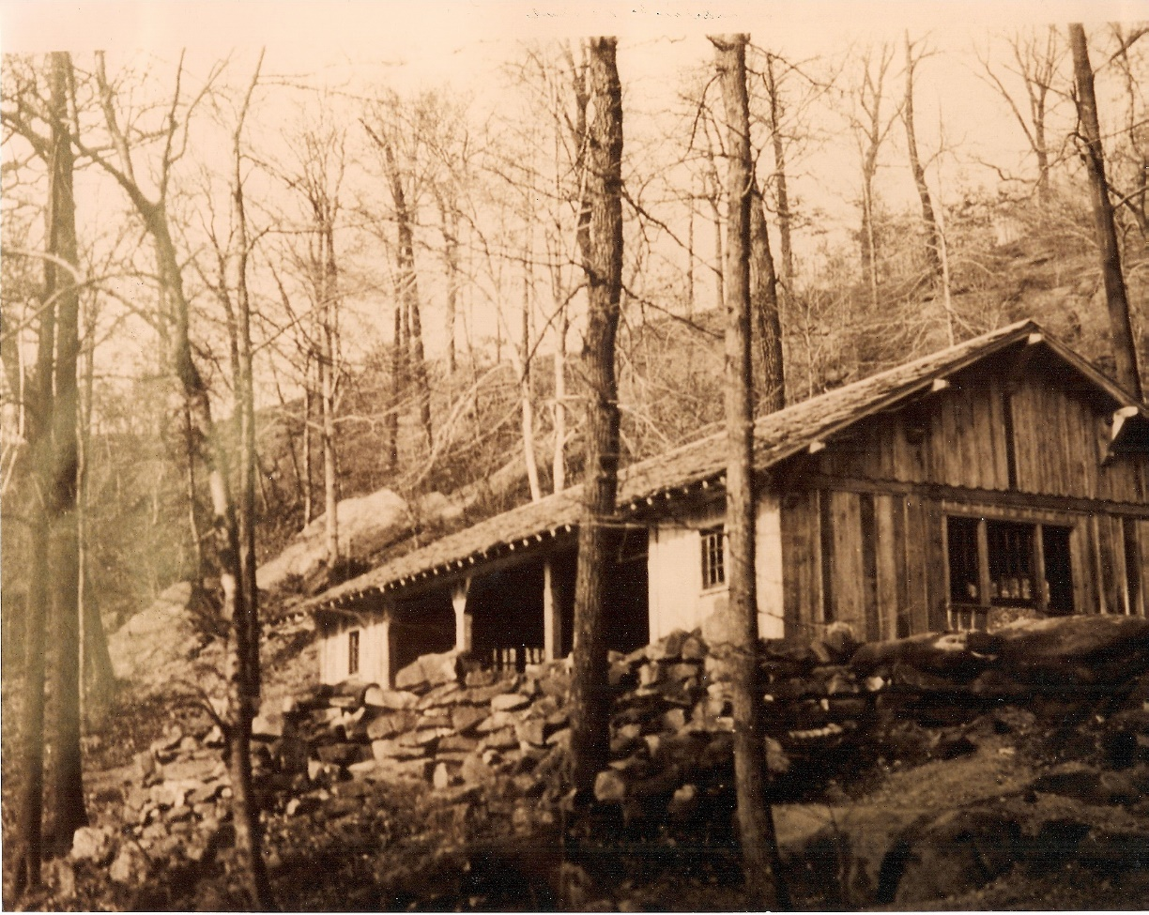
Picnic Shelter shown shortly after construction, 1937 (Summit Metro Parks)
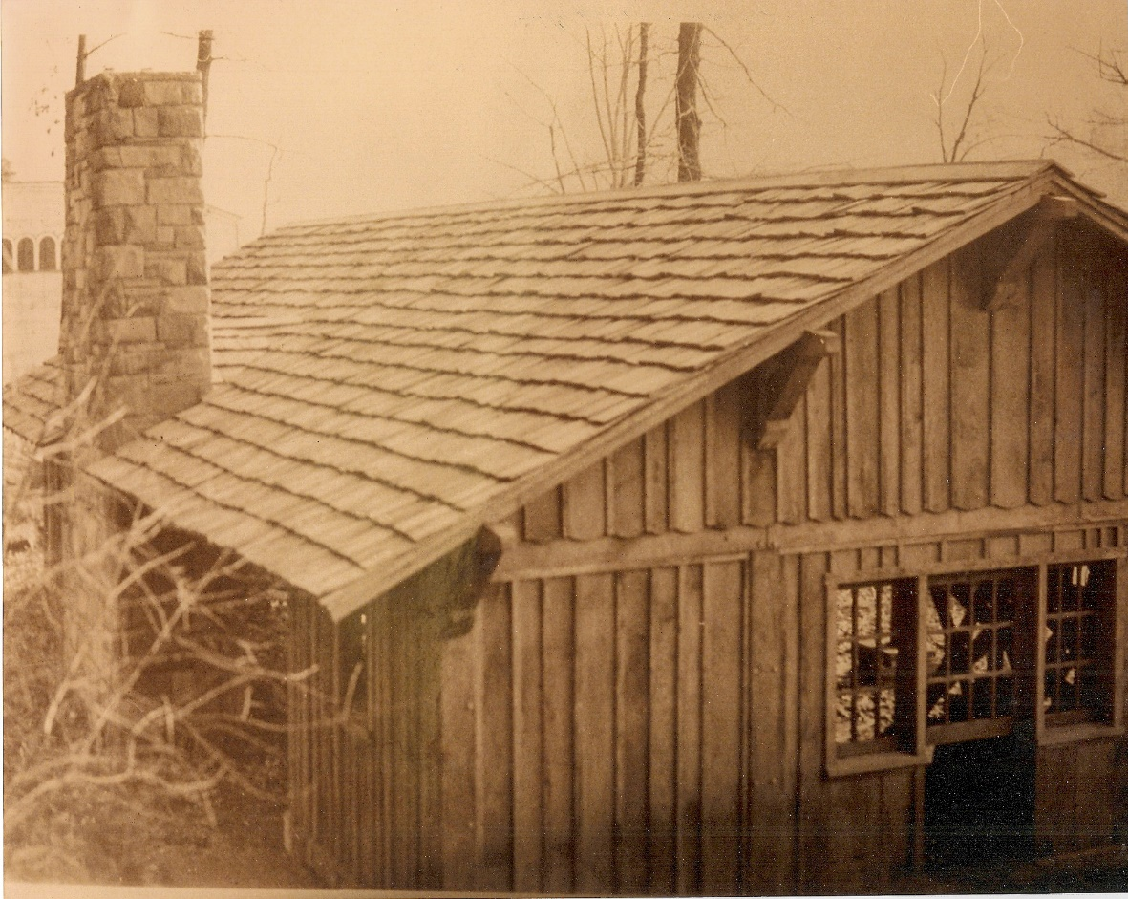
Picnic shelter as viewed from the west. The Riverview park dance hall, The Roseland, can be seen in the background. 1937. (Courtesy Cuyahoga Falls Historical Society)
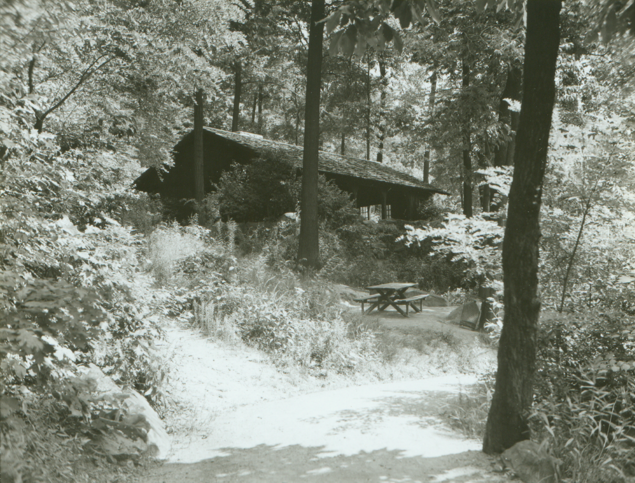
The Gorge shelter with its walls removed, 1939. (Summit Metro Parks)

Old Maid’s Kitchen
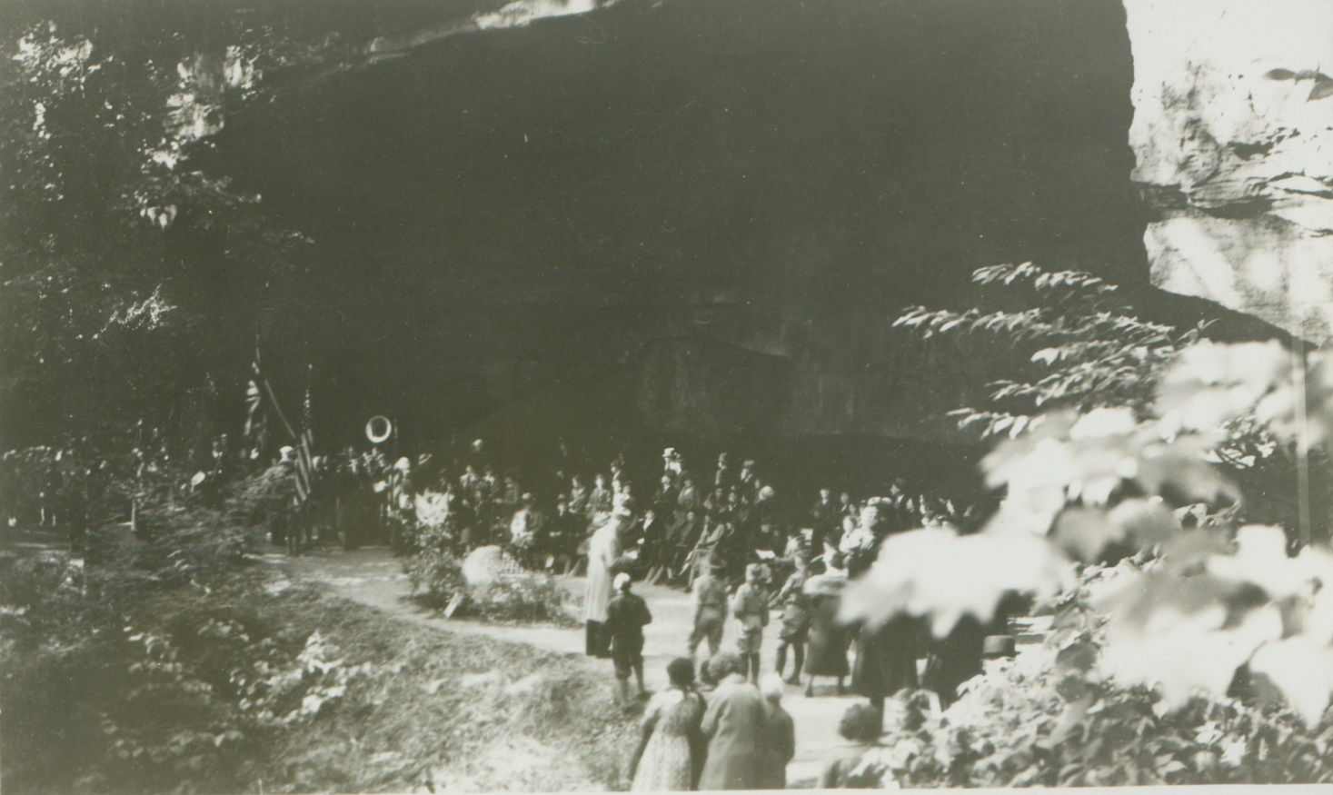
Old Maid’s Kitchen during the Mary Campbell Memorial Dedication, 1935 (Summit Metro parks)
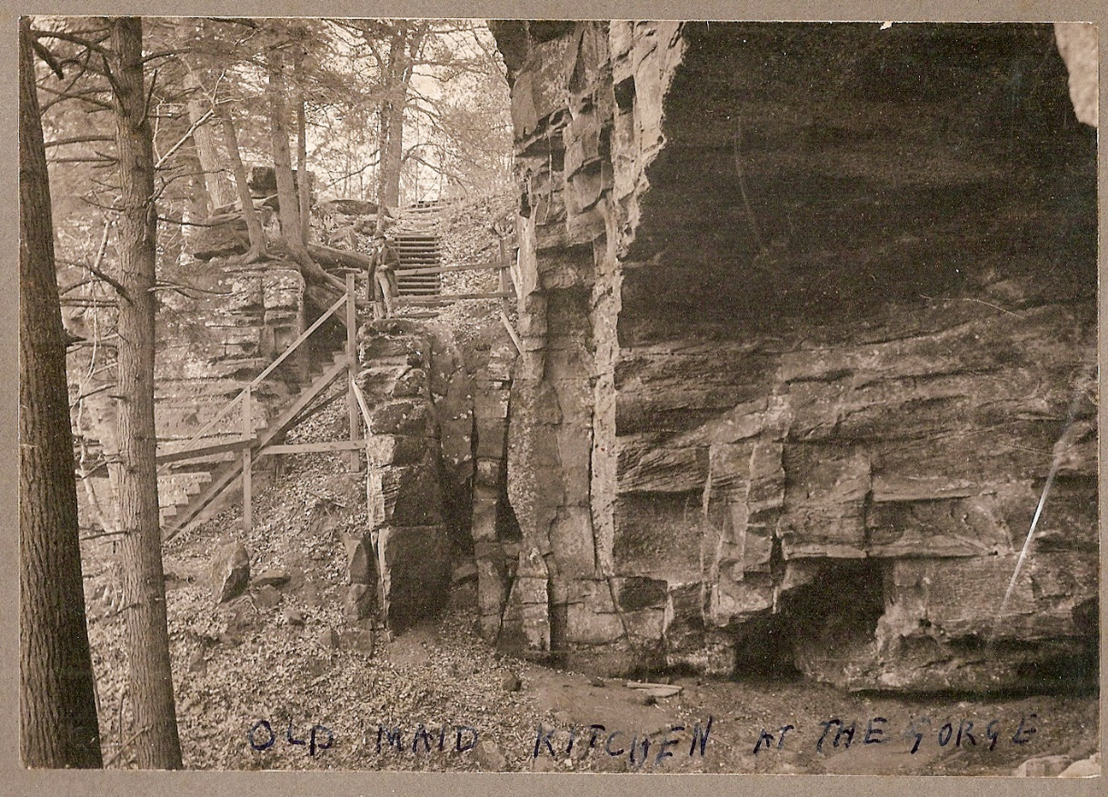
Old Maid’s Kitchen showing staircase from above, unknown date. (Courtesy Cuyahoga Falls Historical Society)
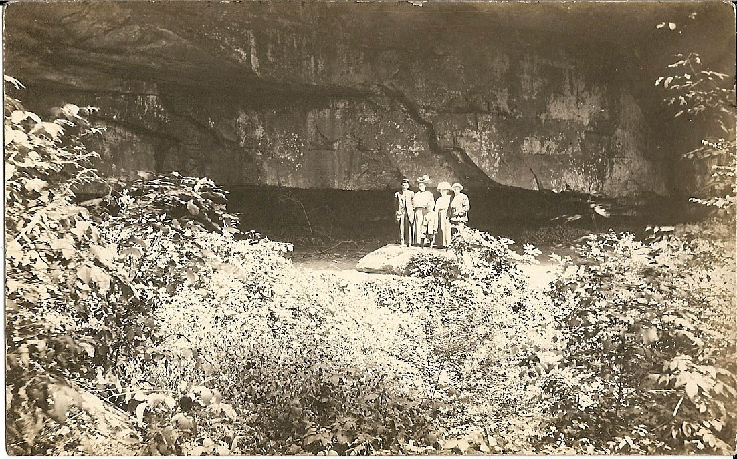
Victorian visitors at Old Maid’s Kitchen, date unknown. (Courtesy Mary McClure)

Natural Attractions
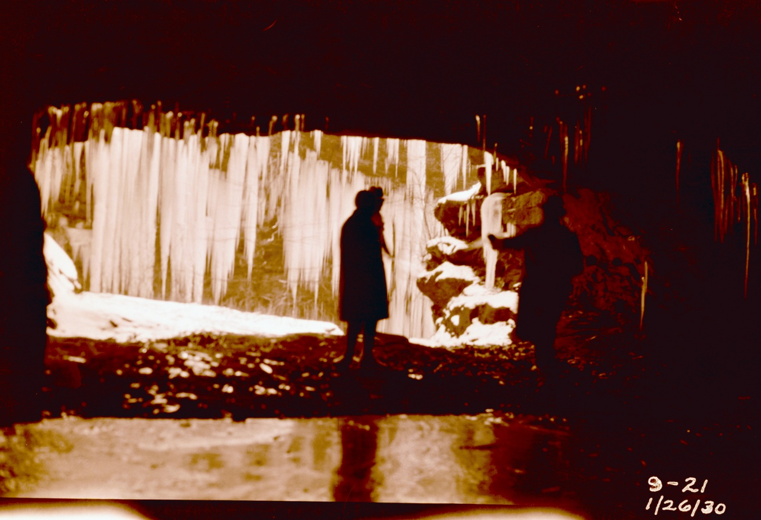
Visitors inside unknown cave, January 1930 (Summit Metro Parks)
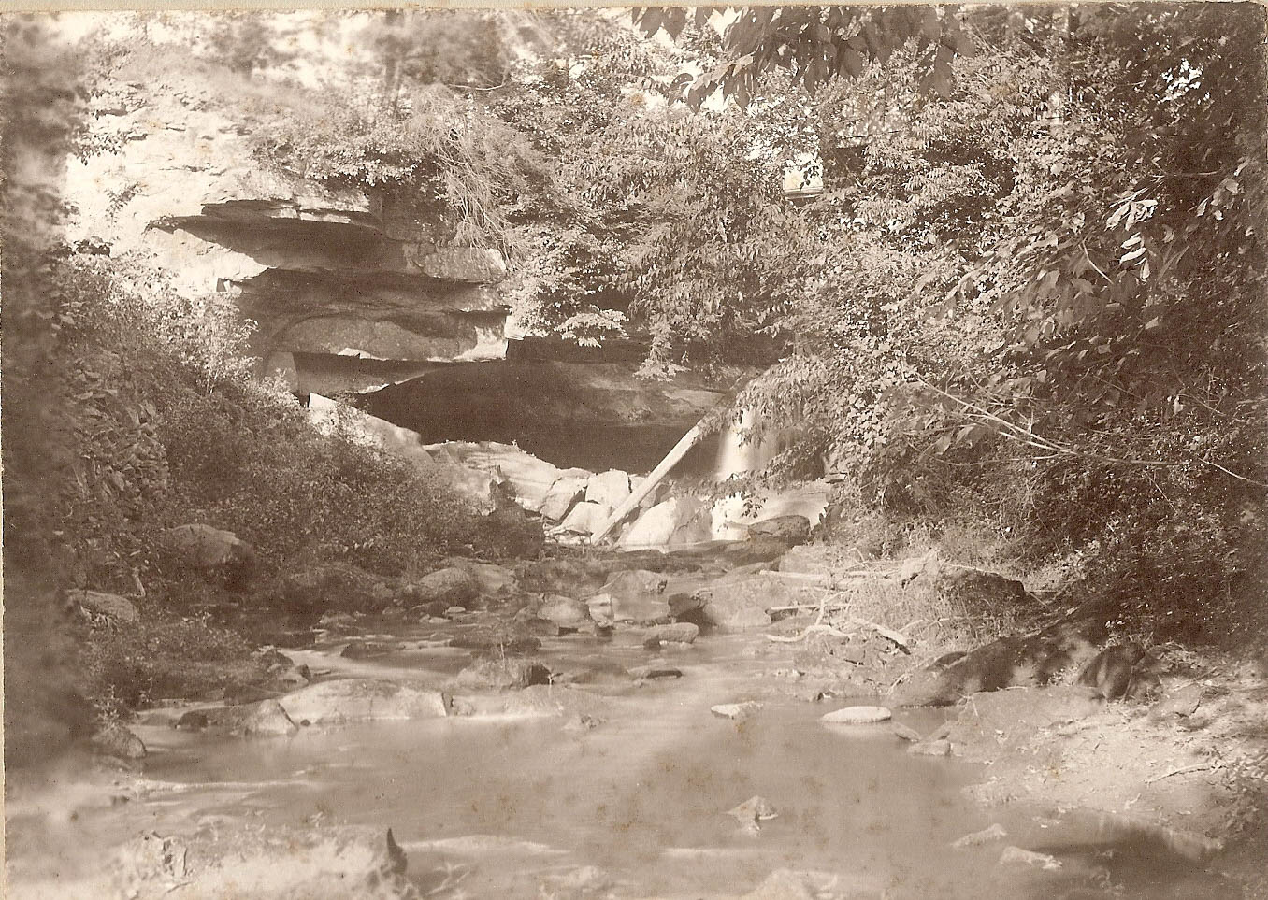
Unknown cave, possibly Fern Cave, date unknown (Summit Metro Parks)
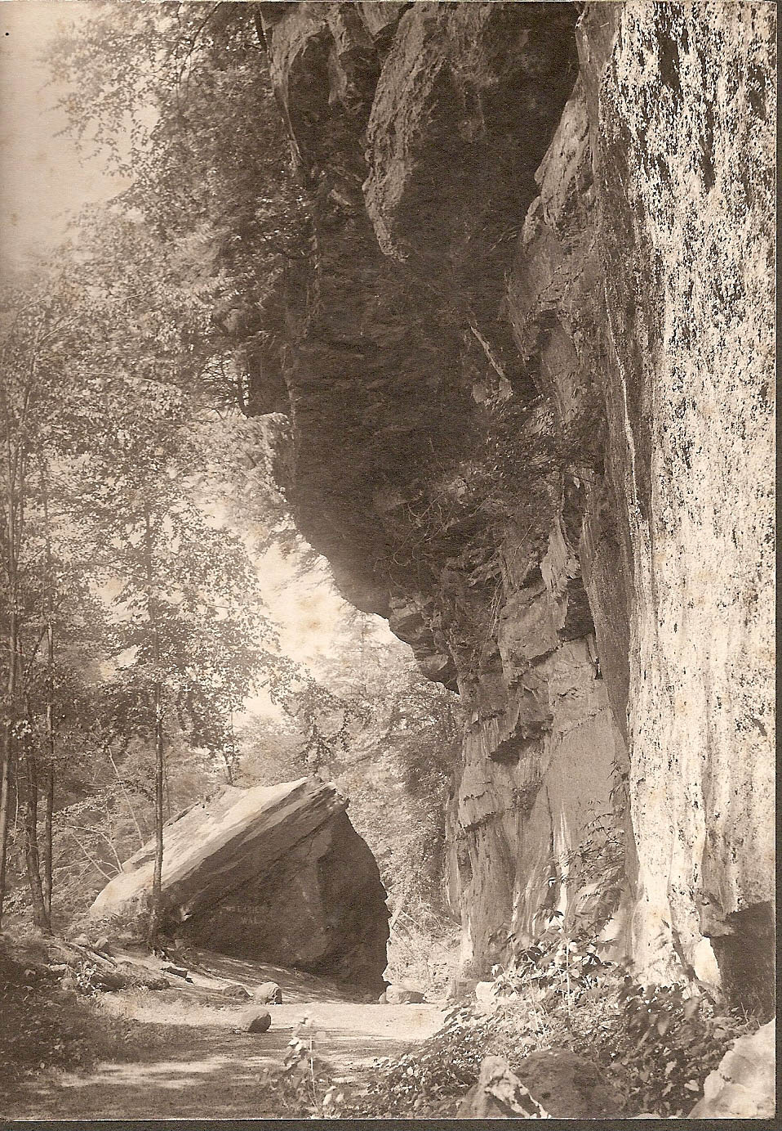
Cathedral Rock at the beginning of the Chuckery Race, date unknown (Courtesy Cuyahoga Falls Historical Society)
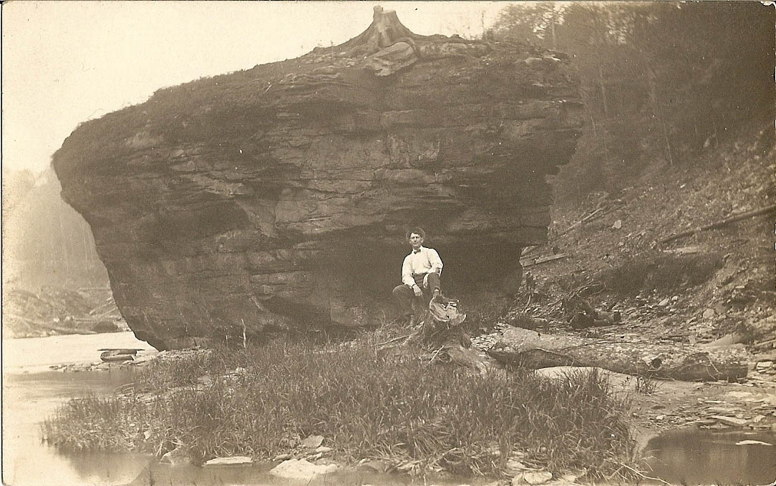
Visitor near large rock located in original river bed, date unknown (Courtesy Mary McClure)
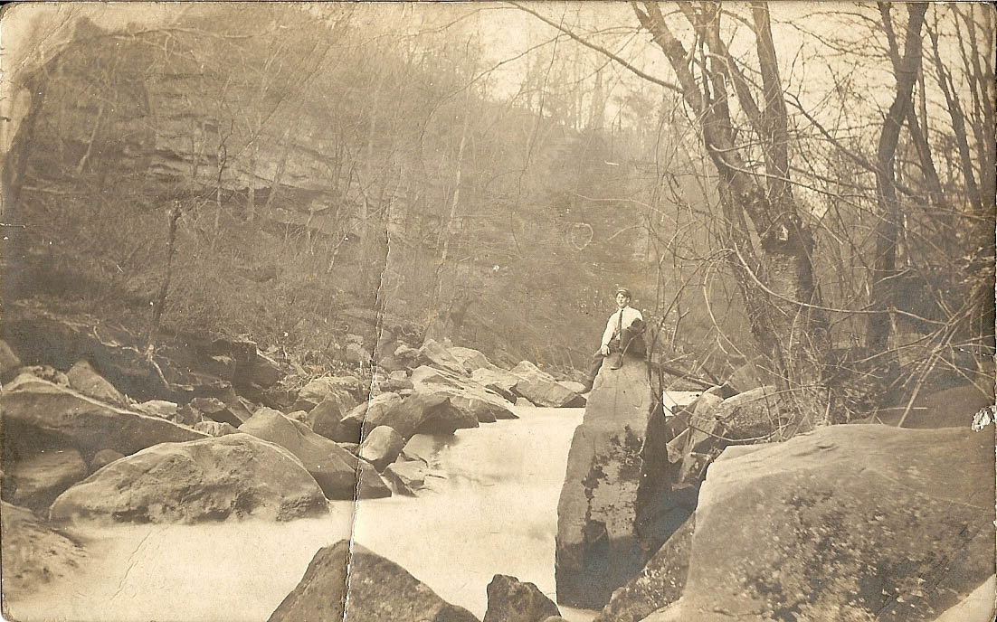
Visitor to Gorge along original river bank, date unknown (Courtesy Mary McClure)

Original Big Falls
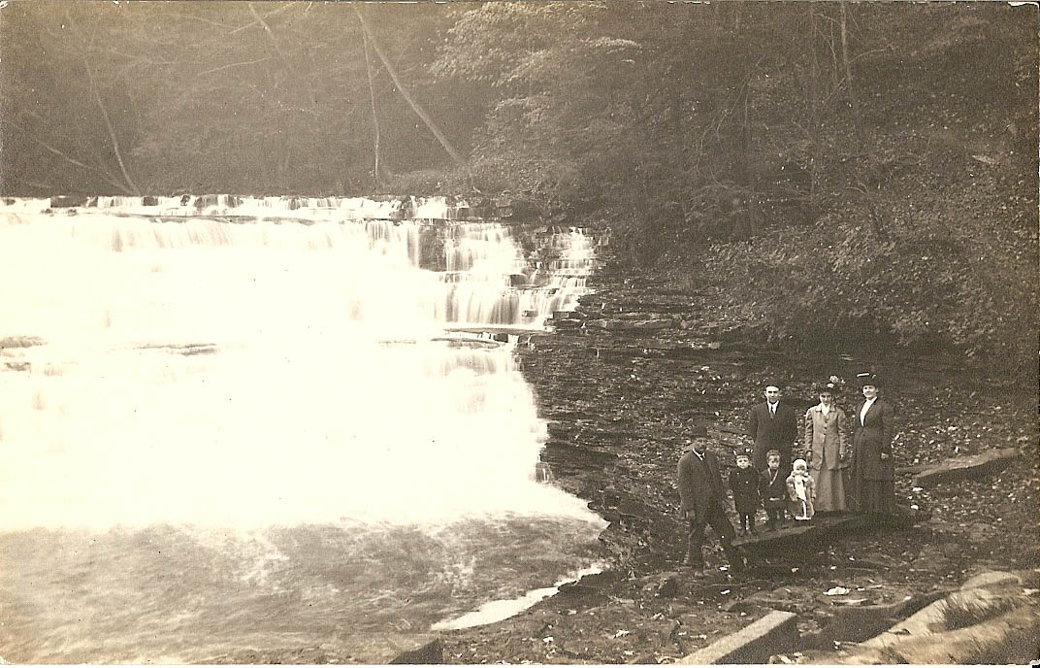
Victorian visitors to the Big Falls, date unknown (Courtesy Mary McClure)
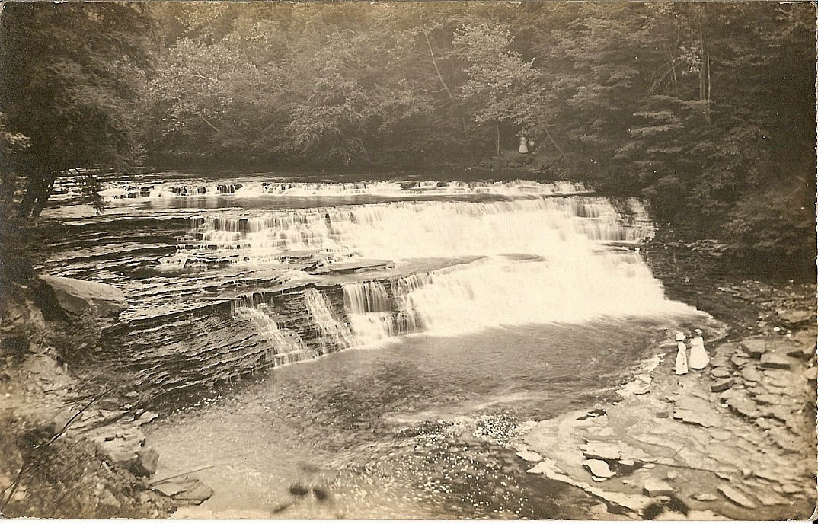
A view of the Big Falls. Victorian visitors shown in front of and on trail behind on the southern bank. (Courtesy Mary McClure)

